PCIe x8 Intel X710 Quad-Port 10G SFP+ Converged Adapter

MC-PCIE-7219
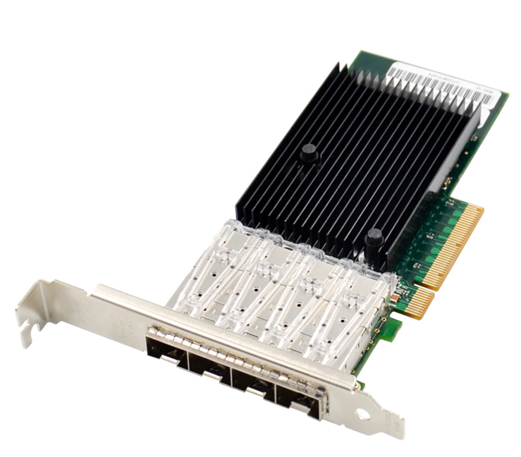

Description
PCIe x8 Intel X710 Quad-Port 10G SFP+ Converged adapter is used 710 series implements a PCIe v3.0 x8 host interface, which operates at up to 8GT/S or 64Gb/s .It provides complete functionality to support four 10Gb/s ports, the device perform all functions required for transmission and reception as specified in IEEE Std. By providing unmatched features for Server and network virtualization, small packet performance ,and low power ; the data center is flexible, scalable, and resilient.
Specification
- PCI-Express host interface specification v3.0 x8 and higher
- Supports the PCI Bus Power Management specification and section 5 of the PCI Express Base Specification
- PCI-Express lanes: x8
- Quad-port 10GbE adapters
- Network Virtualization offloads including VXLAN, NVGRE, Geneve and Network Service Headers.
- Intel Ethernet Flow director for hardware based application traffic steering.
- Intelligent offloads to enable high performance with Intel Xeon processor-based servers
- Packet checksum offloads: Calculates IP,UDP, TCP, and Stream transmission Protocol checksums for insertion into transmitted packets and for integrity checking on received packets, Includes support for UDP and TCP checksums in both IPv4 and IPv6 data grams.
- I/O virtualization innovations for maximum performance in a virtualized server
- Support for optional End-to-End CRC generation and checking
- Supports up to 1024 LAN queue sets(768 typically available)
- Supports up to 384 VSIs with average of two TCs allocated per VSI
- Supports up to 16VEB/VEPA switching components
- Supports Network standard:IEE802.3 10GBASE-SR ,10GBASE-LR,10GBASE-CR
- IEEE802.3x flow control support
- IEEE802.3Q VLAN support with VLAN tag insertion, with stripping and packet filtering for up to 4096 VLAN tags.
- Jumbo Frame support 9728 bytes
- Chipset: Intel XL710-BM1
Package content
- 1 x PCIe x8 Intel X710 Quad-Port 10G SFP+ Converged adapter
- 1 x User’s Manual
- 1 x CD Driver
- 1 x Low profile bracket
- Accessories
System Requirements
- FreeBSD, Linux , VMWare ESXi, Win-server2012 R2/ Win-server2008 R2/
- One available PCI Express x8/x16 slot
Cabling Requirements:
Intel 10Gigabit adapters
- SFP+ Module Laser wavelength:850 nanometer (not visible)
- LC Cable type:
- Multi-mode fiber with 50 micron core diameter, maximum length is 550 meters
- Multi-mode fiber with 62.5 micron core diameter, maximum length is 275 meters
- Connector type: LC
- SFP+ Module laser wavelength:1310 nanometer(not visible)
- LC Cable type:
- Multi-mode fiber with 9 micron core diameter, maximum length is 3K meters
- 10 Gigabit Ethernet over SFP+ Direct Attached cable(Twinaxial)
- Length 10 meters max.
m

Hardware installation
- Turn off the computer and unplug the power cord
- Remove the computer cover and the adapter slot cover from the slot that matches your adapter
- Insert the adapter edge connector into the slot and secure the bracket to the chassis
- Replace the computer cover ,then plug in the power cord
- Power on the computer
Install Drivers and software
Windows Operating Systems
You must have administrative rights to the operating system to install the drivers.
- insert the CD driver bound with Intel network driver into your CD-ROM drive(also you can download the latest drivers from support website):
- if the Found New Hardware Wizard screen is displayed, click Cancel
- start the autorun located in the software package, the autorun may automatically start after you have extracted files.
- Click install Drivers and Software
- Follow the instructions in the install wizard to finish it.
Installing Linux Drivers from Source Code
- Download and expand the base driver tar file.
- Compile the driver module.
- Install the module using the modprobe command.
- Assign an IP address using the ifconfig command.
Support
More information and settings, please refer to the Intel Adapter User Guides or you can contact us.

