PCI Express 17V358 PRO 8S-Port Multi I/O Card

MC-PCIE-338
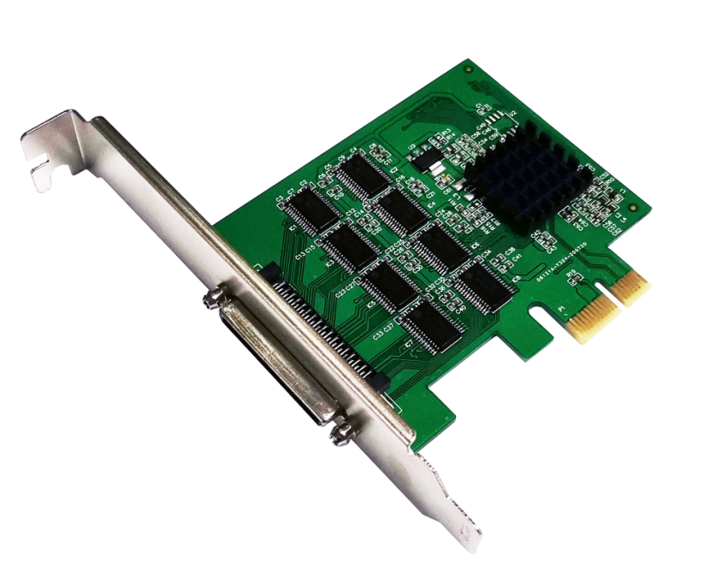

Description
The PCI Express RS232 Multi-Port I/O card is used EXAR’s high performance chipset 17V358,it is compliant to PCIe 2.0 Gen 1(2.5GT/s),and it has eight serial port each port has many enhanced features such as the 256-bytes TX and RX FIFOs, Programmable Fractional Baud Rate Generator, Automatic Hardware or Software Flow control, it is complete to used for Point-of-Sale systems, Remote Access Servers, and factory Automation etc.

Specification
- Compliant with PCI Express Specification Revision 2.0
- X1 link dual simplex .2.5Gbps in each direction
- Supports x1,x2,x4,x8 ,x16(lane)PCI Express slots
- Supports with 8-Port RS232
- 16 multi-purpose inputs/outputs(MPIOs)
- 16-bit general purpose timer/counter
- Up to 31.25Mbps serial data rate
- Data bits:5,6,7 or 8
- Stop bits:1,1.5,2
- Parity check: Even/odd/mark/space/none
- Flow control :none, hardware and Xon/Xoff
- 256-byte TX and RX FIFOs
- TX/RX FIFO level counters
- Automatic RTS/CTS or DTR/DSR hardware flow control with programmable hysteresis
- Multi-drop with Auto Address detection
- Infrare (IrDA 1.1) data encoder/decoder
- Operating temperature range:-40 to 85℃

Package content
- 1 x PCI Express RS232 Multi-Port I/O card
- 1 x User’s Manual
- 1x CD driver
- 1 x Low profile bracket
- 1 x serial 68pin to 9pin cable

System Requirements
- Windows2000/XP/Server2003/Vista/Win7/Win8/Win8.1 /win10, 32 or 64bit
- Linux2.6.27,2.6.31,2.6.32,3.x.x and later
- An available PCI Express X1/X2/X4/X8/X16 Slot

Applications:
- Next generation Point-of sale systems
- Remote Access Servers
- Storage network management
- Factory automation and Process Control

Hardware Signal:
RS232 DB9 Signal
1 | DCD(Data carrier Detect)
2 | RXD(Received Data)
3 | TXD(Trasmitted Data)
4 | DTR(Data Terminal Ready)
5 | GND(signal Ground)
6 | DSR(Data Send Ready)
7 | RTS(Request to Send)
8 | CTS(Clear to Send)
9 | RI(Ring Indicator)
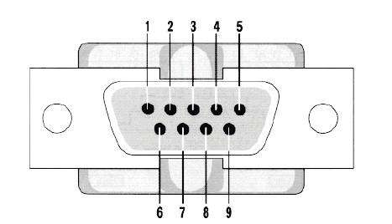
Hardware installation
- Turn off the computer and unplug the power cord
- Remove the computer cover and the adapter slot cover from the slot that matches your adapter
- Insert the adapter edge connector into the slot and secure the bracket to the chassis
- Replace the computer cover ,then plug in the power cord
- Power on the computer

Drivers installation
All the drivers for the following PCI Express cards are located in these directories of the drivers CD
Installing windows driver for the controller card
- once windows is running, insert the drivers CD into the CD-ROM assume drive D
- when the windows ask for the driver for the new hardware, browse to the following folder :
type: D:\XR17V38X\XR17V385……(8S)
- Press OK to confirm
- Press Next to continue with the installation
- Follow the On-screen instruction until driver installation is completed
Verify Driver installation
- When the driver installed, you can use Windows “Device Manager” to verify proper installation. click on the “Programs and Features” tab in the windows “ Control Panel”
Start > Control Panel >Device Manager
- you should see the board under Multi-Port serial adapters, also you should see eight “Exar’s communications port” under Ports(COM&LPT)
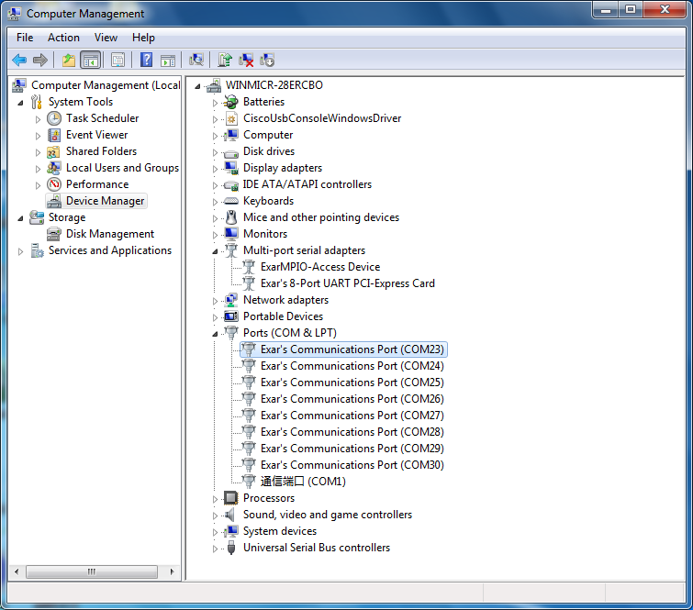

Serial Port Setting
Right click the “Exar’ Communications port” item from the “Ports(COM&LPT)” sub-tree and click “Properties” ,click “Port settings” tab.
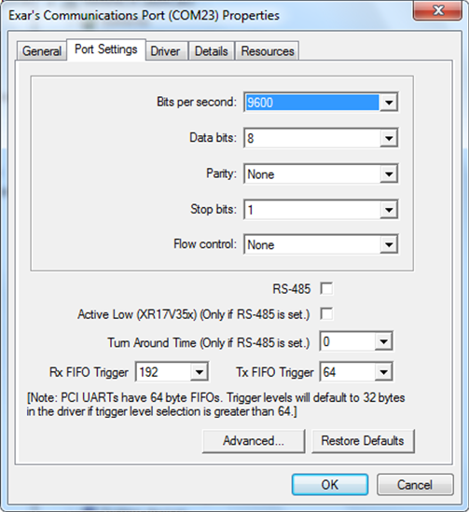

Support
More information and settings, please refer to the User Guides or you can contact us.

