CAT8.1 S/FTP Network cable
Low Smoke Zero Halogen, AWG24, CU

Overview
The MicroConnect CAT8.1 Patch Cable is ideal for use in demanding environments where 25Gbps and bandwidth up to 2000Mhz is required. There are 50u´ RJ45 connectors to provide a better connection, latch protection to protect the clip from breaking and meter marking on the boot to easy identify the length of the cable. These cables are graded LSZH halogen-free and all cables are fluke tested to assure the quality you expect and insures the cable will last.

Features
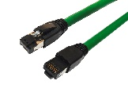
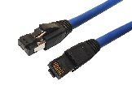
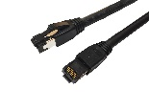
- Patchcable CAT8.1
- Shielded S/FTP
- Jacket: LSZH – Low Smoke Zero Halogen
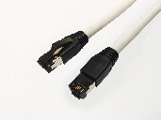
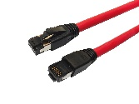
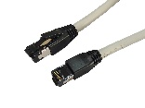
- Latch protection
- PoE: PoE++ ready
- Conductor: CU Cobber
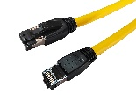
- RoHs, Reach & CE
- Fluke tested

Technical Specification
Model | MC-SFTP8xxxx | Lengths | 0,25m, 0,50m, 1m, 1,5m, 2m, 3m, 5m, 7,5m, 10m,
Miss wire test | 100% open short and miss wire test
Insulation resistance | DC300V 10m ohm | Outer Diameter | 6.0 +- 0.2mm
Dielectric strength | 200V AC/Sec, 1mA | Warranty | 30 Years
Common applications | IEEE802.3 10BASE-T | PoE | Ready for PoE++
 | IEEE802.3 100BASE-T
 | IEEE802.3 1000BASE-T | Testing | Fluke CAT8 Channel link Pass
 | IEEE802.3 10GBASE-T | Wiring standard | EIA/TIA 568B
Colors | Grey, Blue, Green, Red, Black, White & Yellow | Packing | MicroConnect Polybag
 |  | Certifications | CE/Reach/RoHs
 |  | Installation and use | Plug and Play
 |  |  | Indoor

